🧩 COMPLETE DBMS PROJECT BUILD-UP (Bottom-Up)

🟢 PHASE 1 — Schema Creation (Foundation)
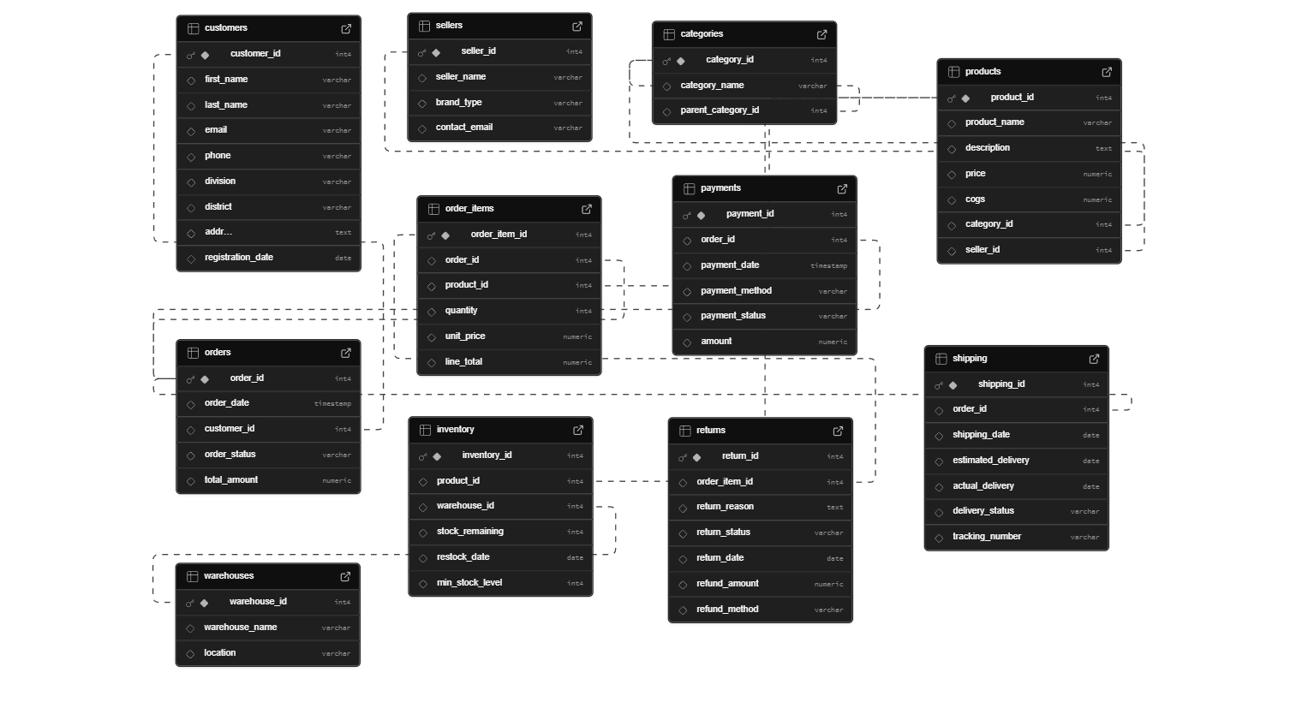

🟡 PHASE 2 — Core Transactional Aggregations (Required Before Analytics)

Dashboard Implementations

1. Daily Sales Dashboard
File: DailySalesDashboard.jsx
Features:
- Year-based filtering (All Years or specific year)
- Summary statistics cards showing:
  - Total Sales
  - Total Orders
  - Items Sold
  - Average Daily Sales
- Interactive visualizations
- Detailed data table with average order value calculation
Charts Used:
- Line Chart - Daily Sales Trend
  - Type: Line chart with area gradient
  - Shows sales amount over time
  - Custom tooltip with formatted currency
  - Formatted Y-axis with K/M notation
- Line Charts (Side-by-Side) - Daily Orders & Items Sold
  - Two separate line charts in grid layout
  - Left: Daily Orders (green gradient)
  - Right: Items Sold (yellow gradient)
  - Gradient fills under lines for visual appeal
  - Interactive tooltips
Data Table Columns:
- Date
- Sales Amount
- Total Orders
- Items Sold
- Average Order Value (calculated)

2. Quantity Sold Dashboard
File: QuantitySoldDashboard.jsx
Features:
- Multiple view types with tab navigation
- Dynamic summary cards that change based on view
- Year filtering for specific views
- Modern gradient-styled buttons
Charts Used:
- Bar Chart (Vertical) - Per Product View
  - Top 20 products by quantity sold
  - Gradient fill (purple to violet)
  - Rounded bar corners
  - Rotated X-axis labels
- Bar Chart (Vertical) - Per Year View
  - Top 10 products for selected year
  - Year dropdown selector
  - Green gradient fill
  - Custom tooltips
- Pie Chart - Per Category View
  - Distribution of quantity sold by category
  - 7-color palette
  - Percentage labels on slices
  - Custom legend with hover effects
  - Interactive color-coded category list
- Bar Chart (Vertical) - Per Category & Year View
  - Top 10 categories for selected year
  - Year dropdown selector
  - Orange/yellow gradient fill
View Types:
- Per Product (all-time top performers)
- Per Year (year-specific product analysis)
- Per Category (category distribution)
- Per Category & Year (category performance by year)
Summary Cards:
- Total Quantity Sold
- Total Products/Categories (dynamic label)
- Average Quantity
- Top Performer

3. Revenue Per Product Dashboard
File: RevenuePerProductDashboard.jsx
Features:
- Year filtering (All Years or specific year)
- Revenue-focused analytics
- Comprehensive data breakdown
Charts Used:
- Horizontal Bar Chart - Revenue by Product
  - All products ranked by revenue
  - Color: Blue gradient
  - Dynamic height based on data count
  - Formatted currency on X-axis (K/M notation)
  - Custom tooltips with product details
Summary Cards:
- Total Revenue
- Total Products
- Average Revenue per Product
- Top Product
Data Table Columns:
- Rank
- Product Name
- Year (conditional - only shown when year selected)
- Total Revenue
- Revenue Share (percentage)

4. Revenue Per Seller Dashboard
File: RevenuePerSellerDashboard.jsx
Features:
- Seller performance analysis
- Year-based filtering
- Multiple visualization perspectives
Charts Used:
- Horizontal Bar Chart - Revenue by Seller
  - All sellers ranked by revenue
  - Color: Blue
  - Dynamic height adjustment
  - Currency formatting
- Horizontal Bar Chart - Products Sold by Seller
  - Quantity metrics per seller
  - Color: Green
  - Number formatting with commas
Summary Cards:
- Total Sellers
- Total Revenue
- Total Products Sold
Data Table Columns:
- Rank
- Seller Name
- Revenue
- Products Sold
- Average Revenue per Product (calculated)

5. Revenue Per Category Dashboard
File: RevenuePerCategoryDashboard.jsx
Features:
- Category-level revenue analysis
- Multiple chart types for comprehensive view
- Year filtering capabilities
Charts Used:
- Pie Chart - Revenue Distribution
  - Percentage-based revenue allocation
  - 8-color palette
  - Percentage labels on slices
  - Interactive legend
- Pie Chart - Products Sold Distribution
  - Quantity distribution by category
  - Matches revenue chart styling
  - Dual-chart layout for comparison
- Horizontal Bar Chart - Revenue by Category
  - Linear representation of category revenue
  - Blue gradient fill
  - Formatted currency axis
- Horizontal Bar Chart - Products Sold by Category
  - Quantity metrics per category
  - Green gradient fill
  - Number formatting
Summary Cards:
- Total Categories
- Total Revenue
- Total Products Sold
Data Table Columns:
- Rank
- Category Name
- Revenue
- Products Sold
- Average Revenue per Product (calculated)
- Revenue Share (percentage)

🟠 PHASE 3 — Time-Based & Customer-Based Metrics
- Monthly Revenue per Year
- Monthly Order Count (Has to be sorted using all years, also per year)
- Monthly Sales Trend (Using 16, 17)
- Average Order Value (AOV)
- Customer Lifetime Value (CLTV)

🔵 PHASE 4 — Advanced Ranking & Segmentation
- Inactive Sellers Detection

🟣 PHASE 5 — Returns, Loss & Risk Analysis
- Most Returned Products (All time, per year, per month(another tab))
- Return Rate per Product (All time, per year, per month(another tab))
- Revenue Loss Due to Returns (All time, per year, per month(another tab))

🔴 PHASE 6 — Functions (Reusable Analytics Layer)
- Monthly Sales Summary Function
  - Function (RETURNS TABLE)
- Customer CLTV Function
  - Function
- Product Profit Margin Function
  - Function
- Seller Performance Function
  - Function
- Revenue Decrease Ratio (YoY) Function
  - Function

🟤 PHASE 7 — Procedures (Controlled Data Mutation)
- Create Order Procedure
  - Procedure (transactional)
- Add Order Items Procedure
  - Procedure
- Update Inventory Procedure
  - Procedure
- Process Return Procedure
  - Procedure
- Mark Order as Shipped Procedure
  - Procedure

⚫ PHASE 8 — Triggers (Automation & Integrity)
- Auto Deduct Inventory on Sale
  - Trigger (AFTER INSERT on order_items)
- Prevent Order if Stock Insufficient
  - Trigger (BEFORE INSERT)
- Auto Update Order Status on Payment Success
  - Trigger
- Auto Restore Inventory on Return
  - Trigger
- Auto Mark Order Completed
  - Trigger (payment + shipping)

🟠 PHASE 9 — Optimization & Intelligence (Exceptional)
- Low Stock Alert View
  - View / Materialized View
- Fraud Pattern Detection Query
  - Query
- Revenue Drop Detection Query
  - Query
- Daily Inventory Snapshot Job
  - Scheduled Procedure

